Hello World Program Explanation -

package com.basic;

public class HelloWorld {

public static void main(String[] args) {

System.out.println("Hello, World!!");

}

}

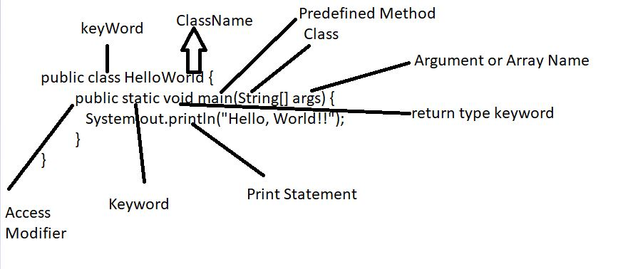

Rules for Variables in Java :-

1) Local variable-

(i) Scope of Variable is within a class/Method.

(ii)Decalre within an method, constructor or blocks.

(iii) Variables are allocated when block executed.

(iv) Stored in stack memory.

(v) Must be intilize before use. Does’nt have any default values.

(vi) We cannot use Access specifier with local variables.

2) Instance variables –

(i) Scope of Instance variable is inside the class but outside method, constructor, or blocks declaration.

(ii) When object is created than memory is allocated.

(iii) Stored in Heap Memory.

(iv) They have default values.

(v) Access specifier can be use.

(vi) It can be called directly

(vii) Have scope inside all method, constructor or blocks.

3) Static Variable –

(i) Declare within an class within a use of static keyword.

(ii) Scope inside all methods.

(iii) When we run a program and .load class is loaded than memory is allocated.

(iv) Stored in non-heap memory or static memory.

(v) Default variables similar to instance variables.

(vi) We can use Access Specifier with static.

(vii) We can access static(directly, by using className, by using Object reference name).

Variable Program -

class Variable {

int a = 10; -----> Instance variable

static int b = 20; ----> Static Variable

void add() {

int c = 30, d; -----> Local Variable

d = a + b + c;

System.out.println(d);

}

void mal() {

int e = 40, f;

f = a \* b \* e;

System.out.println(e);

}

}

Condtional Statement and Loops -

If- Else if - Else -

int a = 10, b = 20, c = 30;

if(a>b && a>c) {

Sop("A is Greater");

}

else if(b>a && b>c) {

Sop("B is Greater");

}

else {

Sop("C is Greater");

}

If - Else -

int a = 10, b = 20;

if(a>b) {

Sop(A is Greater");

}

else {

Sop(B is Greater");

}

While Loop -

classReverseNumber {

public static void main(String [] args) {

int num = 5432, rem, rev = 0;

while(num != 0) {

rem = num%10;

rev = rev \* 10 + rem;

num = num/10;

}

}

}

For(int i=10; i<=num; i++) {

}

For loop steps -

(i) Value initliaze

(ii) condition Check

(iii) Increment

\* -> no .of rows, no.of columns

\* \*

\* \* \*

\* \* \* \*

\* \* \* \* \*

public class Pattern {

public static void main(String[] args) {

for(int i = 1; i <= 5; i++) {

for(int j = 1; j <= i; j++) {

System.out.print("\*");

}

System.out.println();

}

}

}